IH1100 23.07.2024
Add attribute to the UI via Customizing

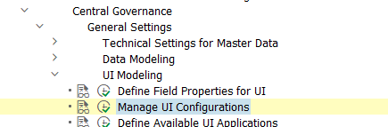

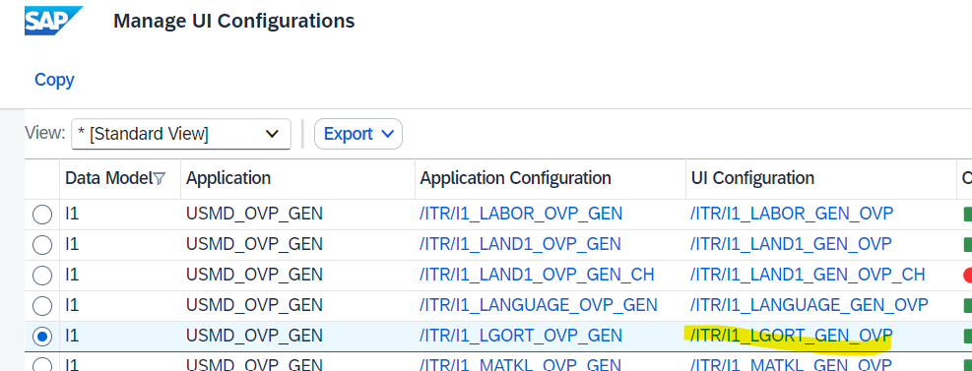

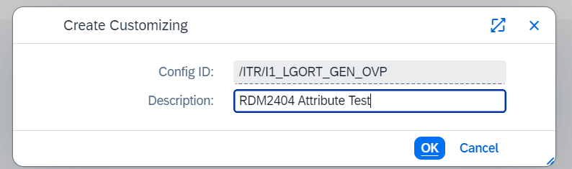
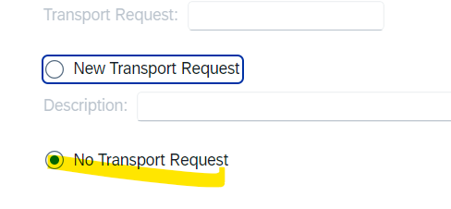
No chance to create a new one?

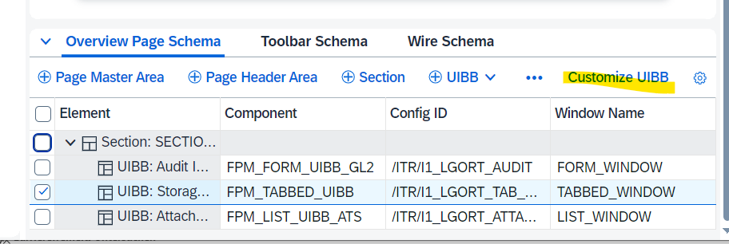
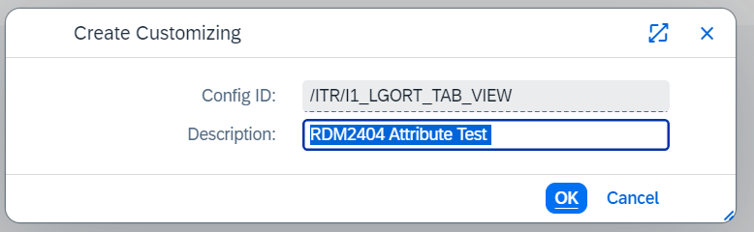

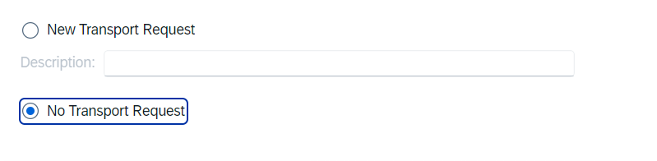

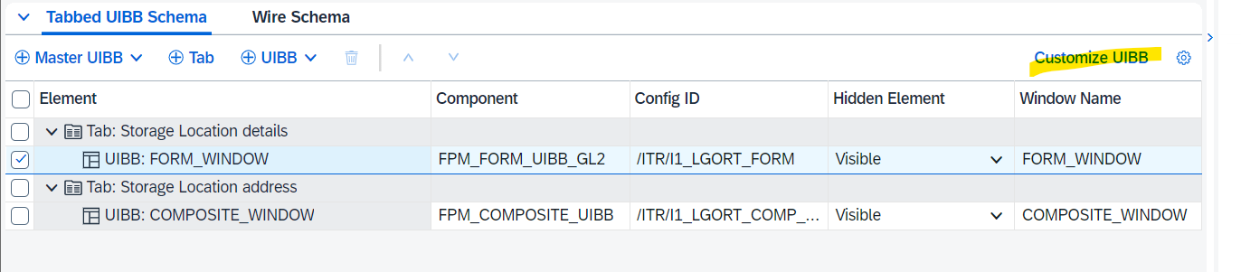

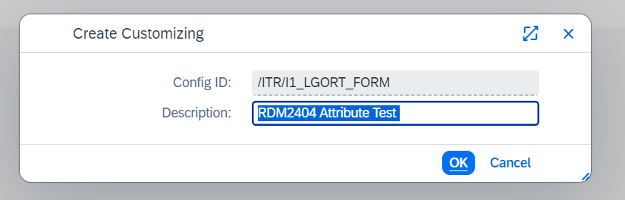

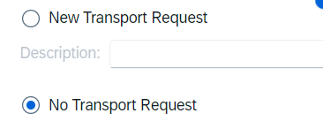

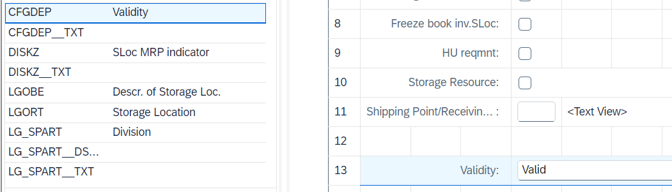

Add attribute to Governance Scope
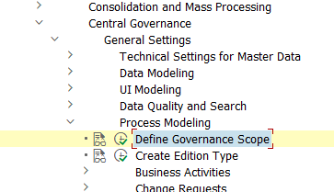

Already active: 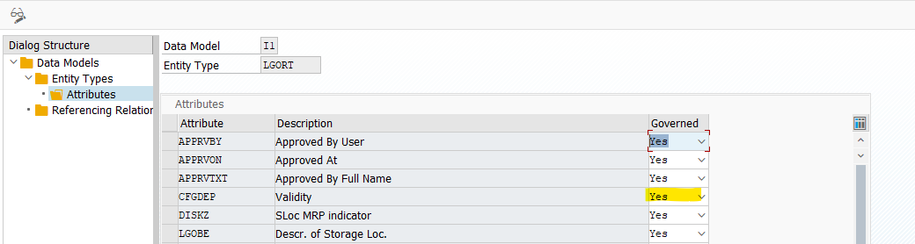
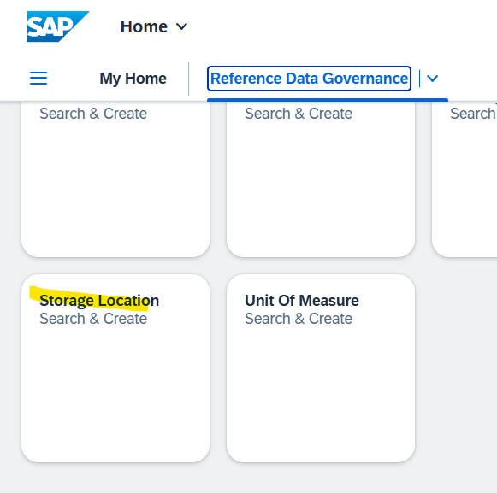

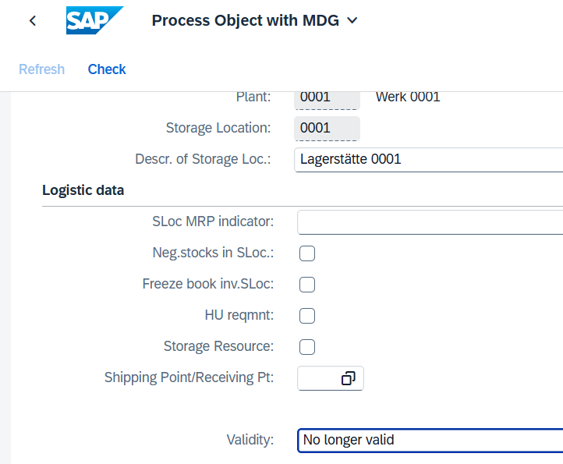

IH1400:

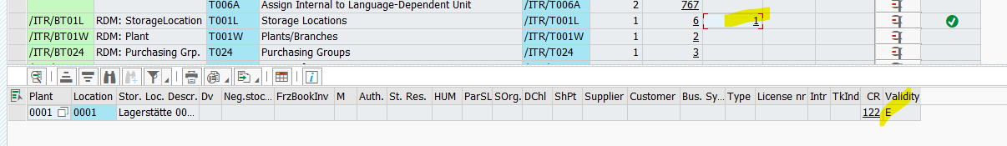

Not updated …
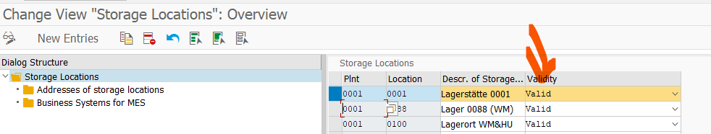

But this is clear as the Local Scope needs to be enhanced:


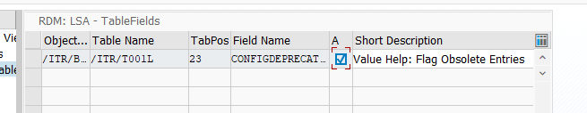

Activated … no transport .. (?)

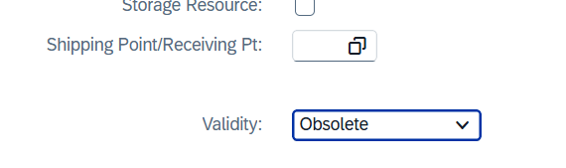
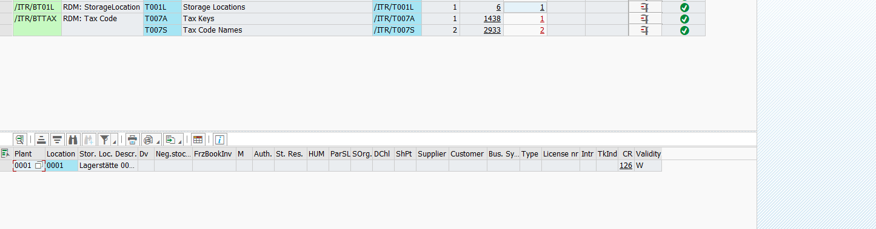
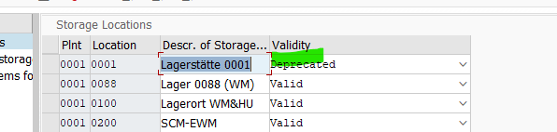

IR1 200:

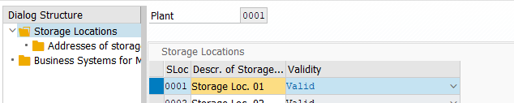

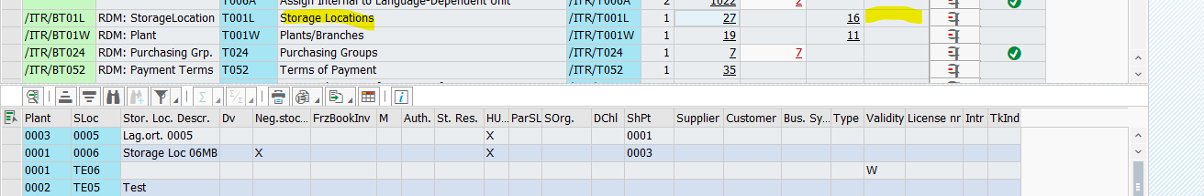



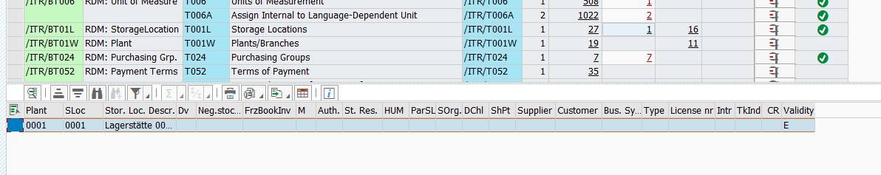

Ok!

IR2200

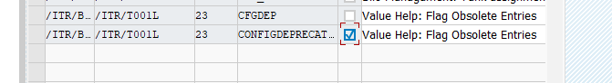

No such field in T001L:
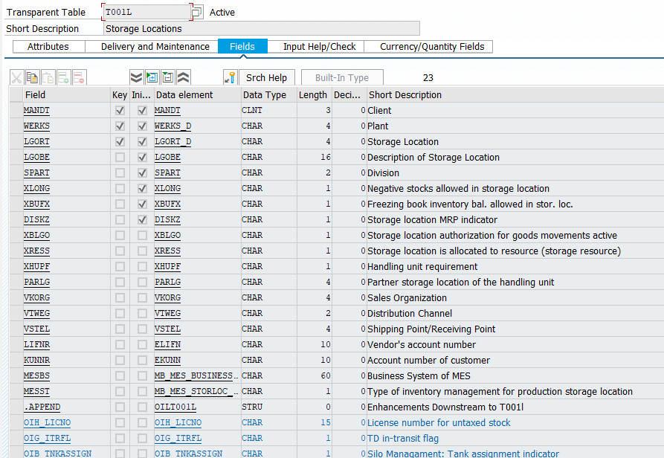
Activation worked … ok!

S01400
Entry in Local Scope has to be added manually:
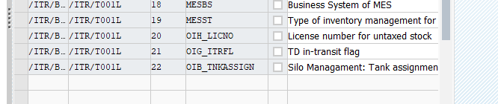
Older RDM release … does not support this new attribute:
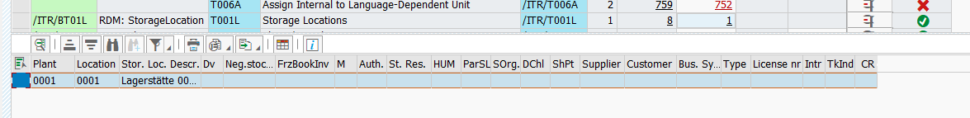
Activation works (w/o new field) => ok!

IR1200 – Business Gov

